Case Study Report



**Tech Saksham**

Data Analytics with Power BI

**Analysis of Cryptocurrency Growth Over the Last 5 Years**

**A.V.P College of arts and science- Tiruppur**

|  |  |
| --- | --- |
| **NM ID** | **NAME** |
| 7CAB4B653469EAC9FE34FB8A23D1FBF5 | ABINAYA S |

|  |  |
| --- | --- |
|  |  |
|  | Trainer Name: UMAMAHESWARI R |
|  | Master Trainer: UMAMAHESWARI R |

**ABSTRACT**

This case study employs Power BI to conduct a thorough analysis of cryptocurrency growth spanning the last five years. Leveraging the tool's robust data visualization capabilities, the study delves into various aspects of the cryptocurrency market, including price fluctuations, market capitalization, trading volumes, and volatility. By meticulously examining historical data and trends, the analysis aims to uncover underlying patterns and key drivers shaping the trajectory of the cryptocurrency landscape. Through interactive dashboards and intuitive visualizations, stakeholders can gain actionable insights into market dynamics, enabling informed decision-making regarding investment strategies, risk management, and market positioning. This study provides a comprehensive understanding of the evolution of the cryptocurrency market, empowering stakeholders to navigate its complexities with confidence and agility.

**INDEX**

|  |  |  |
| --- | --- | --- |
| **Sr. No.** | **Table of Contents** | **Page No.** |
| 1 | Chapter 1: Introduction | 4 |
| 2 | Chapter 2: Services and Tools Required | 6 |
| 3 | Chapter 3: Project Architecture | 7 |
| 4 | Chapter 4: Modeling and Result | 9 |
| 5 | Conclusion | 18 |
| 6 | Future Scope | 19 |
| 7 | References | 20 |
| 8 | Links | 21 |

**CHAPTER 1**

**INTRODUCTION**

* 1. **Problem Statement**

Despite the exponential growth and increasing adoption of cryptocurrencies over the past five years, there remains a significant challenge in comprehensively understanding the underlying trends and dynamics driving this market. Existing data analysis methods often lack the sophistication and interactivity needed to unravel the complexities of cryptocurrency growth, hindering stakeholders' ability to make informed decisions. Consequently, there is a pressing need for a robust analytical framework that can effectively synthesize vast volumes of cryptocurrency data, identify key trends, and provide actionable insights to investors, analysts, and enthusiasts. Addressing this challenge requires leveraging advanced analytics tools such as Power BI to extract meaningful insights from the wealth of data available in the cryptocurrency ecosystem, ultimately enabling stakeholders to navigate this rapidly evolving landscape with confidence and precision.

* 1. **Proposed Solution**

The proposed solution involves harnessing the analytical prowess of Power BI to delve deeply into cryptocurrency growth data. By amalgamating diverse data streams and harnessing Power BI's user-friendly interface, stakeholders can generate dynamic visual representations, interactive reports, and predictive insights. This approach empowers stakeholders to make informed decisions and strategic plans within the dynamic and fast-paced cryptocurrency market. Through this comprehensive analysis, Power BI enables a nuanced understanding of cryptocurrency trends, facilitating agility and precision in decision-making processes.

* 1. **Feature**
* **Comprehensive Analysis:** Provides detailed examination of cryptocurrency growth data.
* **Interactive Visualization:** Offers dynamic charts and graphs for intuitive exploration of trends.
* **Customizable Dashboards:** Tailors dashboards to specific user needs.
* **Real-time Monitoring:** Provides up-to-date data for timely decisions.
  1. **Advantages**
* **Informed Decision-Making:** Stakeholders can make informed decisions regarding cryptocurrency investments and strategies based on comprehensive analysis and insights.
* **Risk Mitigation:** The system enables proactive risk management by identifying trends and potential market movements, allowing stakeholders to mitigate risks effectively.
* **Competitive Edge:** Access to real-time data, advanced analytics, and customizable dashboards provides a competitive edge in navigating the volatile cryptocurrency market.
  1. **Scope**

The project scope includes gathering cryptocurrency data from diverse sources, integrating it for analysis, and presenting key insights through interactive visualizations. Analysis will cover metrics like price fluctuations, market sentiment, and trading volumes, utilizing advanced analytics for forecasting. Customizable dashboards will be developed for tailored user needs, with collaboration features for sharing insights. Real-time monitoring and robust security measures ensure timely decision-making and data protection. Thorough testing, documentation, and support ensure system effectiveness and reliability. Additionally, the project involves ensuring scalability to accommodate growing data volumes and user demands as the cryptocurrency market evolves. It also includes providing user training to maximize utilization and proficiency with the system's features and functionalities.

**CHAPTER 2**

**SERVICES AND TOOLS REQUIRED**

**2.1 Services Used**

* **Cryptocurrency Exchange APIs:** APIs provided by cryptocurrency exchanges to access real-time and historical market data.
* **Social Media Sentiment Analysis Tools:** Services offering sentiment analysis of cryptocurrency-related discussions on social media platforms to gauge market sentiment.
* **Historical Cryptocurrency Databases:** Databases or data providers offering historical price data and other relevant metrics for various cryptocurrencies.

**2.2 Tools and Software used**

**Tools**:

* **Power BI:** Power BI is utilized for data visualization, interactive dashboards, and advanced analytics, providing insights into cryptocurrency growth trends through intuitive visualizations and reports.
* **Cryptocurrency Exchange APIs:** Cryptocurrency Exchange APIs are accessed to retrieve real-time and historical market data from various exchanges, forming the foundation of the project's data collection and analysis efforts.

**Software Requirements**:

* **PowerBI Desktop**: This is a Windows application that you can use to create reports and publish them to PowerBI.
* **PowerBI Service**: This is an online SaaS (Software as a Service) service that you use to publish reports, create new dashboards, and share insights.
* **PowerBI Mobile**: This is a mobile application that you can use to access your reports and dashboards on the go.

**CHAPTER 3**

**PROJECT ARCHITECTURE**

**3.1 Architecture**

**USER FRONTEND BACKEND**

|  |  |  |
| --- | --- | --- |
|  | **HTML 5** | **NODEJS 14.0**  **Database** |

Here’s a high-level architecture for the project:

High-Level Architecture:

**1**. **Data Collection**: Cryptocurrency data is gathered from exchange APIs, social media sentiment analysis tools, and historical databases.

**2. Integration**: Data is integrated into a centralized database or data warehouse for comprehensive analysis.

**3. Analysis and Visualization:** Power BI is used for data visualization and advanced analytics, while machine learning libraries aid in uncovering insights.

**4. Collaboration:** Collaboration platforms enable seamless sharing of reports and insights among team members.

**5. Security:** Robust security measures are implemented to protect sensitive data and ensure compliance.

**6. Real-time Monitoring:** Real-time data streaming services provide up-to-date information, with alerting mechanisms for timely decision-making.

In summary, this architecture offers a robust framework for real-time analysis of cryptocurrency data. Leveraging diverse data sources, advanced analytics tools like Power BI, and collaboration platforms, stakeholders gain valuable insights into cryptocurrency trends and market sentiment. Security measures ensure data protection and regulatory compliance. Customization to project needs and adherence to privacy regulations are paramount. With this architecture, stakeholders can navigate the dynamic cryptocurrency landscape with agility and precision.

**CHAPTER 4**

**MODELING AND RESULT**

**Manage relationship**

The “Crypto Data” file will be used as the main connector as it contains most key identifier (Close, Date, High, Low, Name, Marketplace, Open, Sno, Symbol) which can be used to relates the 8 data files together.

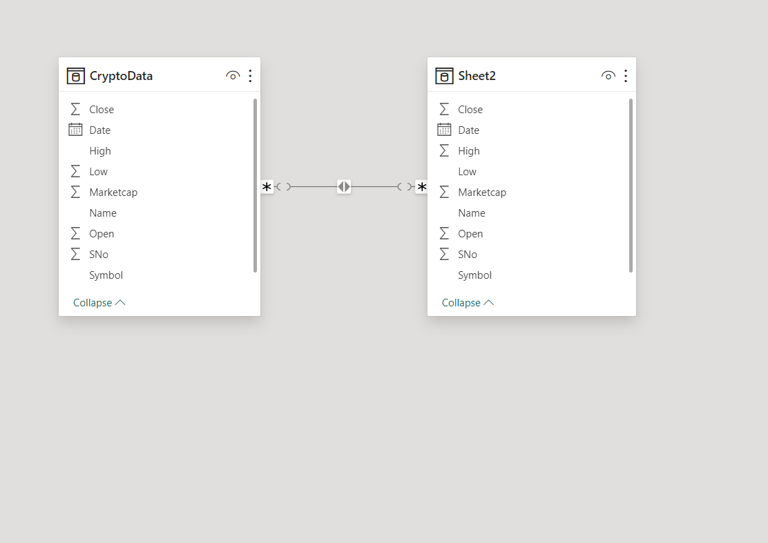

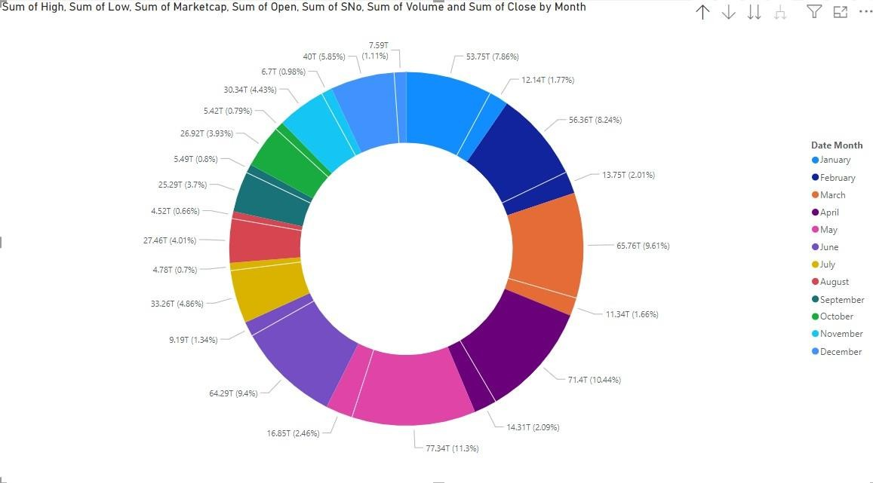

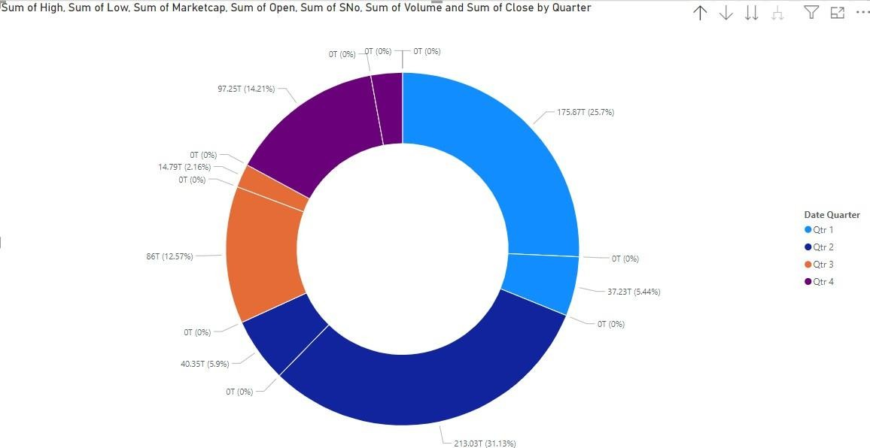

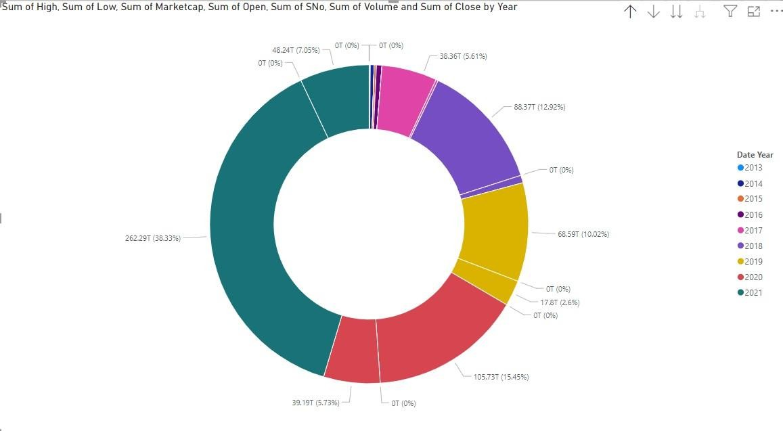

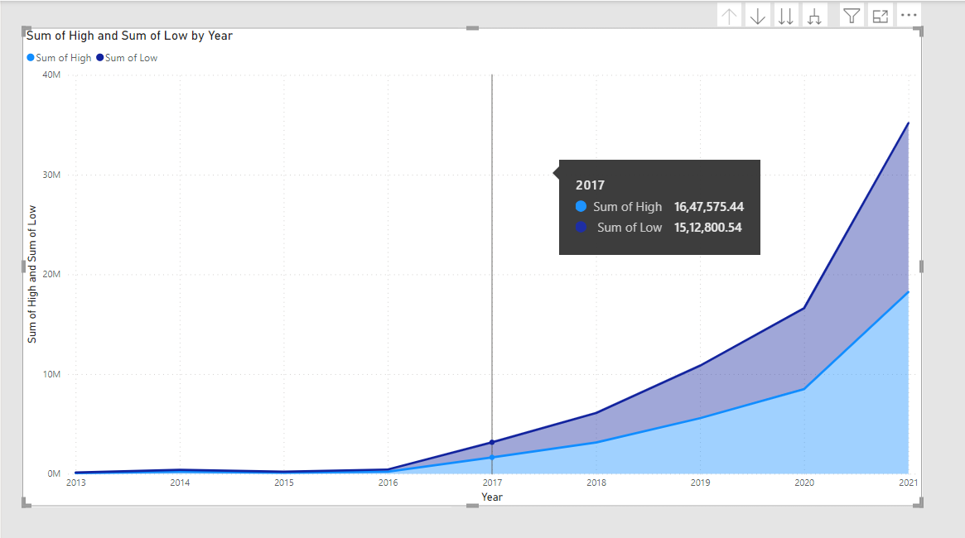

﻿Sum of High (26,534.77% increase) and Sum of Low (27,765.42% increase) both trended up between 2013 and 2021.﻿﻿ ﻿

﻿Across all metrics, Sum of Low had the most interesting recent trend and started trending up on 2017, rising by 1,019.38% (1,54,21,115.32) in 4 years.

﻿Sum of Low jumped from 15,12,800.54 to 1,69,33,915.86 during its steepest incline between 2017 and 2021.

**DASHBOARD**

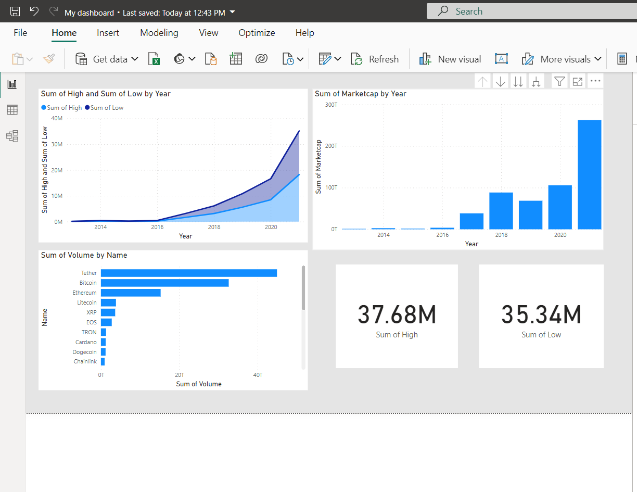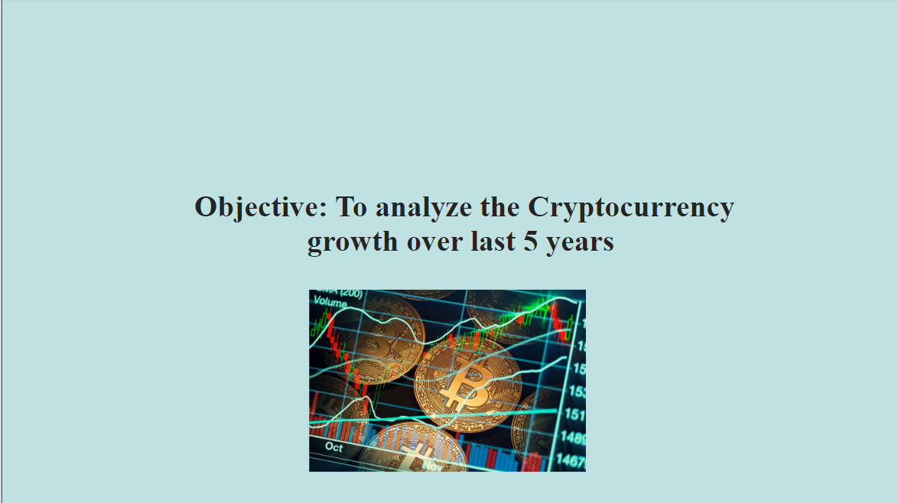

**CONCLUSION**

In conclusion, this project represents a pivotal step towards harnessing the vast potential of cryptocurrency data analysis. By amalgamating cutting-edge technologies like Power BI for visualization and machine learning algorithms for predictive analytics, the architecture provides a robust framework for real-time insights. Collaboration platforms foster synergy among stakeholders, facilitating agile decision-making and strategic planning. Moreover, the emphasis on security ensures the integrity and confidentiality of sensitive cryptocurrency data, while customization allows adaptation to specific project needs and regulatory requirements. With this architecture, stakeholders are equipped to unlock actionable insights, mitigate risks, and capitalize on emerging opportunities in the ever-evolving cryptocurrency market landscape, driving innovation and growth in the digital economy.

**FUTURE SCOPE**

The future scope of this project is expansive, reflecting the dynamic nature of the cryptocurrency landscape and the ever-growing opportunities for innovation. Moving forward, there is potential for enhanced predictive analytics through the refinement and expansion of machine learning models, enabling stakeholders to anticipate market trends with greater accuracy. Additionally, integrating additional data sources such as blockchain analytics and social media sentiment could provide deeper insights into market dynamics. Exploring decentralized finance (DeFi) integration and developing regulatory compliance solutions are also promising avenues for future development. Optimizing scalability and performance, leveraging AI-driven trading strategies, ensuring cross-platform compatibility, and offering education and training programs are vital for staying ahead in the rapidly evolving cryptocurrency ecosystem. By embracing these future opportunities, the project can continue to evolve and meet the evolving needs of stakeholders, driving innovation and creating value in the cryptocurrency space.

**REFERENCES**

<https://www.atharvasystem.com/powerbi-cryptocurrency-data-analytics-dashboard/>

<https://youtu.be/NSuszVGdeKQ?si=f5zFnez628PVGQsJ>

**LINK**

<https://github.com/githubtraining/hellogitworld.git>